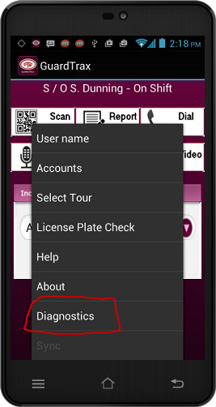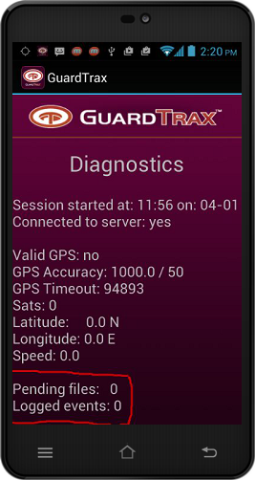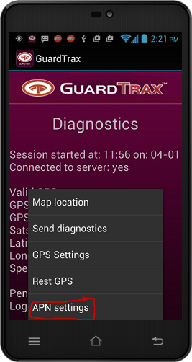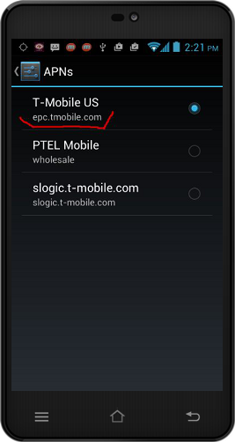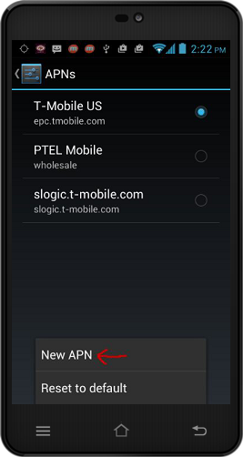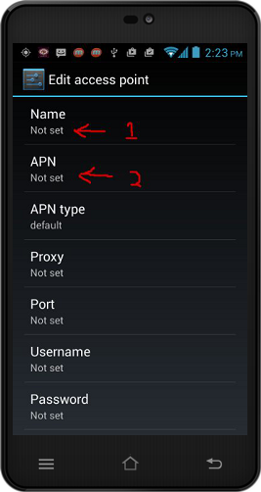

From the same screen, click the menu key again, then click “APN Settings”

Check to see if there are pending files in the device. If yes

Click Menu -> Diagnostics

Set the Name field (1) to “T-MOBILE”

Set the APN field (2) to “epc.t-mobile.com”

SAVE.

Check the current APN settings.

The APN should be “epc.t-mobile.com”

If not, then 

From the same screen click “New APN”